**Data Visualization in Spreadsheets**

**Using Sheets as a Business Intelligence Platform**

#### **Business Intelligence and Using Dashboards**

Learn about business intelligence and dashboards for analyzing information in todays data-driven world. Create a basic dashboard and master setting up your data to get the most out of it.

**1. Sheets as a Business Intelligence platform**

G'day! I'm Raina, welcome to this course on data visualization with spreadsheets! Data visualization has become the number one way to showcase analyzed data. Rather than looking at a huge amount of data analyzed in a spreadsheet, it is much easier for an audience to understand a visual representation of the data. This visual representation is called a dashboard.

**2. Why use spreadsheets?**

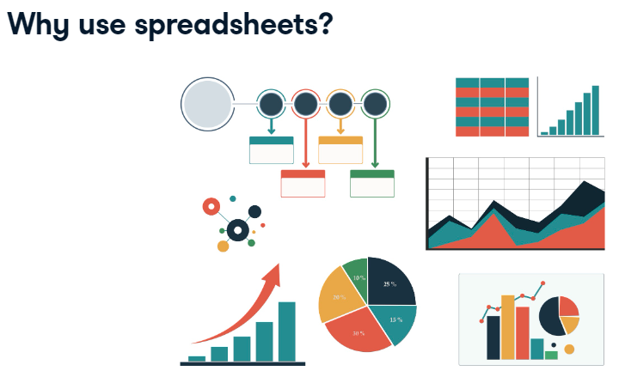

So why use spreadsheets? Most computer users have had at least some dealings with spreadsheets, those in the corporate and commercial environment more so. Because of its familiarity, flexibility, and the tools available to analyze data, spreadsheets are the most widely used Business Intelligence, or BI, tool in the world. In a nutshell, BI is the strategies, methods, and technologies that a business uses to produce meaningful information, that can be used to enhance decision making. It's about providing a complete picture through analyzing and combining data.

**3. How does Business Intelligence help us?**

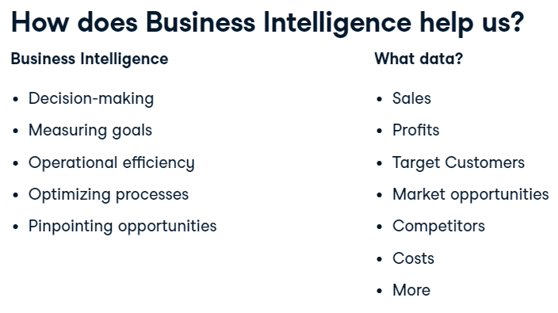

BI helps in strategic decision making, measuring goals, increasing operational efficiency, optimizing business processes, and pinpointing business opportunities, through identifying problems, market trends, and new markets. So, what specific data will help you make informed decisions? It could include sales, profits, target customers, market opportunities, competitors, costs, and more. A dashboard is the perfect tool to display data in a visual way. It is an information management tool that will track and present your analyzed data according to criteria you have specified.

**4. What message are you trying to convey?**

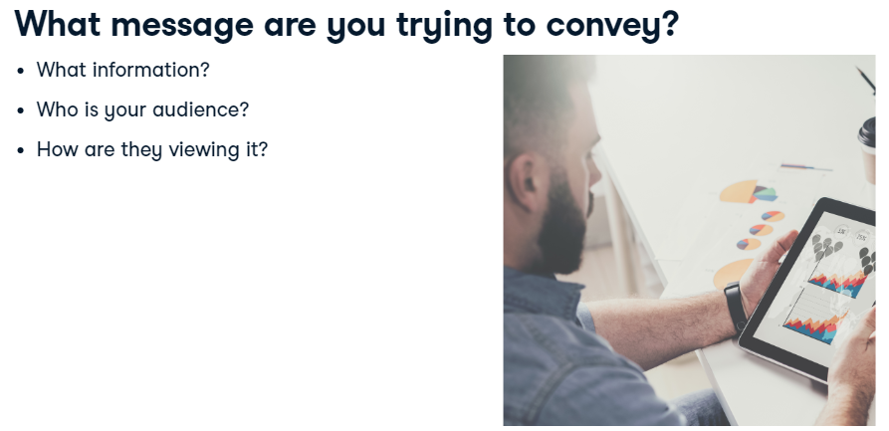

Now that you know what Business Intelligence and data visualization are, you can look at creating a basic dashboard. Before you begin though, think about what information you need. What information are you trying to get across? Who is your audience? Are they viewing the information on a big screen, a desktop, laptop, tablet, or mobile phone? What visualization best displays your data?

**5. What else matters?**

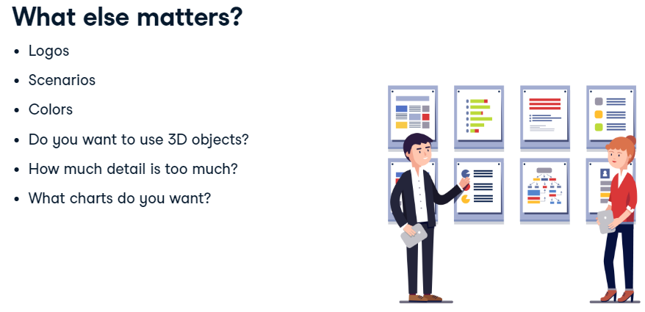

And what else matters? Do you need a logo? Will you show different scenarios? What about company colors? Will your audience print in color or view on-screen? What about 3D objects? Sometimes these can just confuse the message. Consider how much detail you want. The detail shown should only be the data you need. What charts do you want? Your charts are visual and should grab your reader's attention, so it is vital that you select the right chart for the right job. In this course, you will dabble with data visualization, and eventually create your own working dashboard that will showcase statistics relating to shark attacks in Australia.

**6. What functions does a dashboard use?**

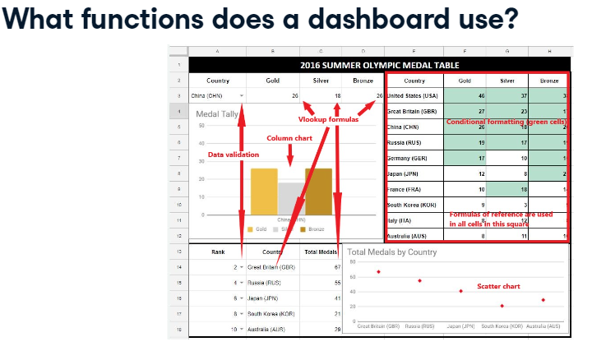

The dashboard you are going to create has features similar to the ones shown on the slide. Once your dashboard has been set up, features can be built into it to enable a user to see their desired results, either within the cells or on a chart. The finished dashboard can include features like data validation to select values from a list, VLOOKUP formulas to return data from a specified column, formulas of reference to pull in data from a dataset, and conditional formatting to highlight cells according to criteria.

**7. Different types of charts**

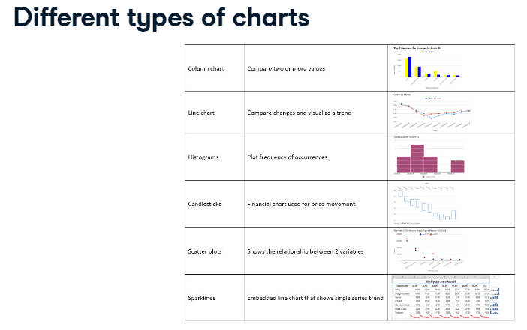

One of the main assets of spreadsheets is their ability to produce charts to plot statistical data. Column and line charts are used for comparison, histograms plot frequency, candlesticks show price movements, scatters show relationships, and sparkline charts show single trends within a cell. We will look at all of these chart types in this course.

**8. Let's practice!**

But first, let's practice modifying a simple completed dashboard to understand how they work and the features used to create them.

#### (1) Using data validation controls view medal tallies

In this completed basic dashboard example, you'll find the medal statistics by country taken from the 2016 Olympic Games held in Brazil.

You are going to use the data validation controls to view the gold, silver, and bronze medal tallies for Australia.

##### Instructions

* Change the country to Australia using the drop-down menu.

#### (2) Using data validation controls to pick from a list

In the dashboard example, you are going to pick sequential numbers from a list to order countries by medal rankings. In this exercise, you will be sorting the countries by total number of medals, but country rank in the Olympics is typically determined by the number of Gold medals per country. Ties are broken using silver medals, and then bronze medals.

##### Instructions

* Change the rank using the drop-down menu so that the ranks are displayed in order for countries 1 through 5.

#### (3) Using conditional formatting on a dashboard

Conditional formatting is another functionality that completed dashboards can contain that allows users to modify the visual display on the dashboard. Here, you will explore the conditional formatting on the same dashboard for the 2016 Olympic Games in Brazil.

There is already a conditional formatting rule set that highlights medal counts greater than or equal to 15. Your task is to adapt this rule so that the dashboard only highlights cells **greater than or equal to 25**.

##### Instructions

* Highlight Gold, Silver, and Bronze figures for the 10 countries and adapt the existing 'Conditional formatting' rule (Value is greater than or equal to 15) to instead highlight values that are greater than or equal to **25**.

#### **Setting up a basic dashboard**

## 1. [1.] Setting up a basic dashboard [Temel bir gösterge panosu ayarlama]

Now that you have seen a completed dashboard and used features to modify the display, let's discuss setting one up! [Artık tamamlanmış bir kontrol paneli gördüğünüze ve ekranı değiştirmek için özellikleri kullandığınıza göre, şimdi bir tane ayarlamayı tartışalım!]

## 2. [2.] Dashboard features [Pano özellikleri]

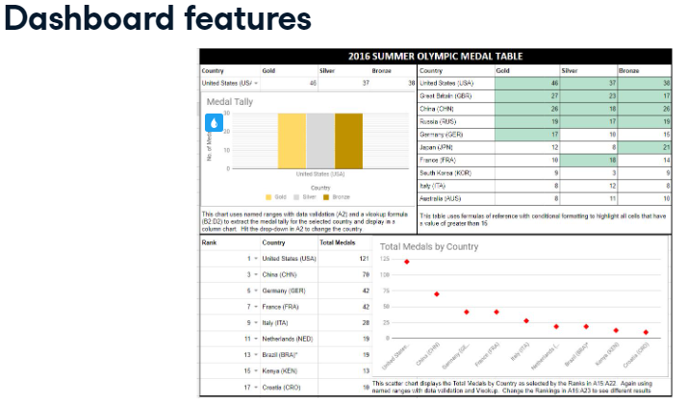

The simple dashboard has user-friendly functions and controls to show only the data you want to report and uses the right visualization to showcase this data. [Basit gösterge panosu, yalnızca bildirmek istediğiniz verileri göstermek için kullanıcı dostu işlevlere ve kontrollere sahiptir ve bu verileri sergilemek için doğru görselleştirmeyi kullanır.] You will explore this further as you set up and add features to your own dashboard, which will allow you to pull data from your main dataset. [Ana veri kümenizden veri çekmenize izin verecek olan kendi gösterge tablonuza özellikler kurarken ve eklerken bunu daha fazla keşfedeceksiniz.] Using VLOOKUPs and formulas of reference, drilling data down further using data validation, plotting it, highlighting cells that meet certain criteria and using conditional formatting will make this easy. [DÜŞEYARA ve başvuru formüllerini kullanmak, veri doğrulamasını kullanarak verilerin detayına inmek, bunları çizmek, belirli kriterleri karşılayan hücreleri vurgulamak ve koşullu biçimlendirme kullanmak bunu kolaylaştıracaktır.] When creating a dashboard, you need to ensure you include the right tools to grab your audience's attention, so start with the outcome in mind and work backwards. [Bir gösterge panosu oluştururken, hedef kitlenizin dikkatini çekmek için doğru araçları eklediğinizden emin olmanız gerekir, bu nedenle sonucu göz önünde bulundurarak başlayın ve geriye doğru çalışın.]

## 3. [3.] Getting your data right for the dashboard [Verilerinizi kontrol paneli için doğru hale getirme]

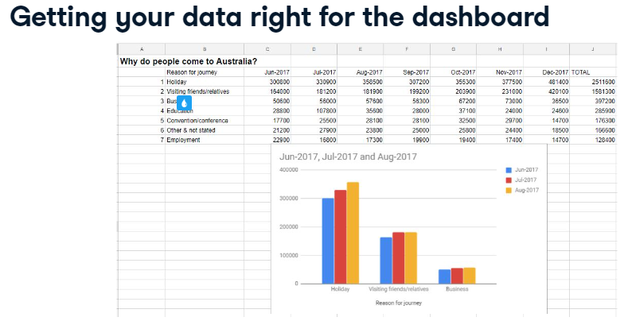

Before creating a chart, think about what data you are going to use. [Bir grafik oluşturmadan önce, hangi verileri kullanacağınızı düşünün.] What is it and where is it located? [Nedir ve nerede bulunur?] Is it in the same workbook, pulled from the net, copied, linked, or imported from another source? [Aynı çalışma kitabında mı, ağdan mı alındı, kopyalandı mı, bağlantılı mı yoksa başka bir kaynaktan mı alındı?] Depending on where it comes from, the format may need tweaking a little bit, or a lot. [Nereden geldiğine bağlı olarak, formatın biraz veya çok fazla ayarlanması gerekebilir.] It's best practice to get your data in order first as this is the basis for all your visualizations. [Tüm görselleştirmelerinizin temeli bu olduğundan, önce verilerinizi sırayla almak en iyi uygulamadır.] We will talk more about how you can optimize your data a little later. [Verilerinizi nasıl optimize edebileceğiniz hakkında biraz sonra konuşacağız.]

## 4. [4.] Extracting your data [Verilerinizi çıkarma]

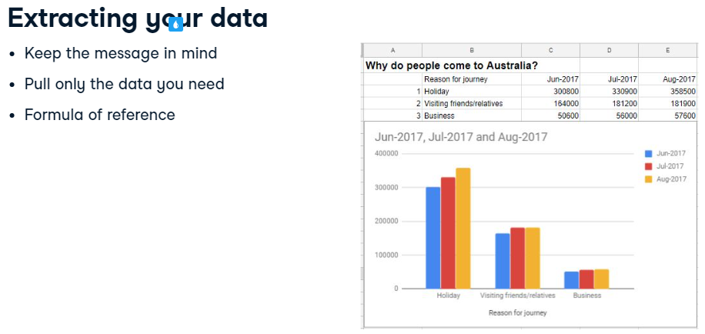

A smart dashboard displays only the information you want your user to see. [Akıllı bir gösterge panosu, yalnızca kullanıcınızın görmesini istediğiniz bilgileri görüntüler.] You should not display your entire data set. [Tüm veri kümenizi görüntülememelisiniz.] It takes up too much room and draws the reader's eye away from the main message of the visualization because the sheet is too busy. [Sayfa çok meşgul olduğu için çok fazla yer kaplar ve okuyucunun gözünü görselleştirmenin ana mesajından uzaklaştırır.] The best way to create a dashboard is to keep your datasets on separate sheets and selectively pull the data you wish to display to create a chart. [Bir pano oluşturmanın en iyi yolu, veri kümelerinizi ayrı sayfalarda tutmak ve bir grafik oluşturmak için görüntülemek istediğiniz verileri seçerek çekmektir.] A formula of reference is the perfect tool for this! [Bir referans formülü bunun için mükemmel bir araçtır!] It's a simple formula that shows the value of a cell in another cell on the same sheet, or another cell in a different sheet. [Aynı sayfadaki başka bir hücredeki veya farklı bir sayfadaki başka bir hücrenin değerini gösteren basit bir formüldür.] This also ensures that each time you feed off the dataset you are using the same data and, if the dataset is edited or updated, the changes will be reflected. [Bu aynı zamanda, veri kümesini her beslediğinizde aynı verileri kullandığınızı ve veri kümesinin düzenlenmesi veya güncellenmesi durumunda değişikliklerin yansıtılmasını sağlar.]

## 5. [5.] Formulas of reference [referans formülleri]

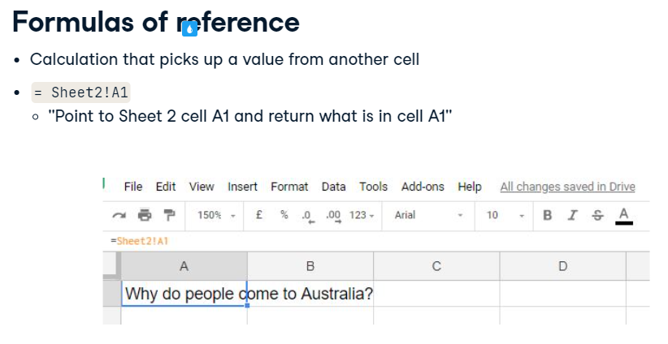

A formula of reference is a basic calculation that picks up a value from another cell. [Başvuru formülü, başka bir hücreden bir değer alan temel bir hesaplamadır.] It's probably one of the most common formulas you will ever use. [Muhtemelen şimdiye kadar kullanacağınız en yaygın formüllerden biridir.] The formula of reference here is saying "point to Sheet 2, cell A1 and return whatever is in cell A1". [Buradaki başvuru formülü 'Sayfa 2'yi, A1 hücresini işaret edin ve A1 hücresinde ne varsa onu döndürün' diyor.] To start a formula of reference, type in an equals sign. [Bir başvuru formülü başlatmak için eşittir işareti girin.] Then navigate to your cell, on either the current sheet or another sheet, and click enter. [Ardından, geçerli sayfada veya başka bir sayfada hücrenize gidin ve enter'a tıklayın.] Doing so will ensure that if the data in Sheet 2, cell A1 changes, any cell in any sheet that references this will also change. [Bunu yapmak, Sayfa 2, A1 hücresindeki veriler değişirse, buna başvuran herhangi bir sayfada herhangi bir hücrenin de değişmesini sağlayacaktır.]

## 6. [6.] The column chart [Sütun grafiği]

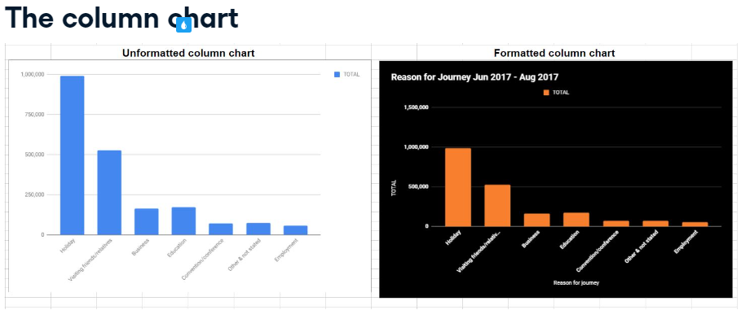

Once you have extracted the data you wish to display, you can create a column chart to plot the results. [Görüntülemek istediğiniz verileri çıkardıktan sonra, sonuçları çizmek için bir sütun grafiği oluşturabilirsiniz.] Column charts are used to visually represent data in vertical, rectangular bars, where the bar length is in proportion to the data. [Sütun grafikleri, verileri çubuk uzunluğunun verilerle orantılı olduğu dikey, dikdörtgen çubuklarda görsel olarak temsil etmek için kullanılır.] They are great for comparing values over time or comparing data from different categories. [Zaman içinde değerleri karşılaştırmak veya farklı kategorilerdeki verileri karşılaştırmak için harikadırlar.] The vertical axis is displayed on the left-hand side of the chart, making it easy for the user to compare the vertical bars visually. [Dikey eksen, grafiğin sol tarafında görüntülenir ve kullanıcının dikey çubukları görsel olarak karşılaştırmasını kolaylaştırır.] You can apply many different types of formatting to your chart, which we will cover in more detail in the next chapter. [Bir sonraki bölümde daha ayrıntılı olarak ele alacağımız, grafiğinize birçok farklı biçimlendirme türü uygulayabilirsiniz.]

## 7. [7.] Let's practice! [Hadi pratik yapalım!]

Time to practice what you have learned. [Öğrendiklerinizi uygulama zamanı.] Have a go at the exercise and see how you go! [Egzersize bir göz atın ve nasıl gittiğinizi görün!]

#### (1) Creating a column chart from your data

In the dataset you'll find the medal statistics by country from the 2016 Olympic Games held in Brazil in order of ranking. Let's use the data to create a column chart to show the medal tallies of the first 3 ranked countries.

##### Instructions

* Highlight the Country, and then the Gold, Silver, and Bronze medal stats for the first three ranked countries, then create a **column** chart and move it to the right of the data.

#### (2) Setting up your worksheet with formulas of reference

In this next task, you will showcase only the data you want to chart using formulas of reference to extract the top 3 countries' medal tallies from the dataset and show them in the dashboard.

##### Instructions

* Create a formula of reference in cell A1 that shows the contents of A1 in the Olympics sheet.
* Copy the calculation down and across the sheet to show all data for the first 3 ranked countries.
* Make sure column B is wide enough to see the entire country name.

#### (3) Charting the medal statistics

Now that you have only the data you want to chart in this task you will create a column chart and display it underneath your extracted data.

##### Instructions

* Create a column chart showing the Country, Gold, Silver, and Bronze stats.
* Position the chart underneath the data.